

**1/15/2022**

**Hospital Management System**

**Advanced Computer Programming**

**Course Code: CSCI217**

**Advanced Computer Programming**

**Presented by:**

**Shrouk Hesham 19106271**

**Hussin Fekry 19105777**

**Seifeldin Mohamed Hashem 19105145**

**Abdelrahman Mahmoud Mari 19104609**

**Toka Hamdy 19105665**

**Asmaa Mohamed 19200036**

**Presented to:**

**Dr. Passant**

**Eng. Zeyad Ezzat**

**Abstract**

In our project, we designed both a human resources management system with a hospital management system for helping improve managements at hospitals and providing the best practices for service human resources departments within the hospital. Our hospital management system allows us the ability to optimize and digitize all the processes within the hospital. In addition, provides a platform for patients in a specific department of the hospital according to the patient’s disease. Furthermore, our system enhances the effectiveness of appointments between patients and doctors. Our proposed system is a designed object-oriented-code in C++ which has so many features and can be useful to both doctors and patients. In our project, we provided an effective application with a graphical user interface, solvable design pattern, and UML using concepts of advanced programming in C++. Our study objective is to improve the quality of medical services and enhancing the managements of the hospitals.

**Table of Contents**

**Abstract………………………….……………………………………………………………..2**

**2.Introductin……………………………………………………………………………………3**

**3.Methodology…………………………………………………………………………………6**

* **3.1 UML Design…………………………………………………………………………….…6**
* **3.2 Design Patterns………………………………………………………………………….9**

**4.Results………………………………………………………………………………………13**

**5.Discussion & Conclusion………………………………………………………………………………….16**

**6. Future Work………………………………………………………………………………17**

**7.Refernces……………………………………………………………………………………18.**

1. **Introduction**

Hospital Management System is an organized computerized system designed and programmed to deal with day-to-day operations and management of the hospital activities. The program can maintain hospital. In this project we are going to build a hospital management system with a HR system in object-oriented code with C++ designed to help improve patient and doctor at hospitals. The project Hospital Management system includes registration of patients, storing their details into the system. The software has the facility to give a unique id for every patient and stores the details of every patient and the staff automatically. It includes a search facility to know the current status of each room. User can search availability of a doctor and the details of a patient using the id. Hospital Management System is powerful, flexible, and easy to use and is designed and developed to deliver real conceivable benefits to hospitals. Hospital Management System that provides relevant information across the hospital to support effective decision making for patient care. Hospital Management System is a software product suite designed to improve the quality and management of HR and hospital management. In addition, it enables you to develop your organization and improve its effectiveness and quality of work.

**Problem Introduction:**

* Lack of immediate retrievals: - The information is very difficult to retrieve and to find particular information. For example, to find out about the patient’s history, the user has to go through various registers. This results in convenience and wastage of time.
* Lack of immediate information storage: - The information generated by various transactions takes time and efforts to be stored at right place.
* Lack of prompt updating: - Various changes to information like patient details or immunization details of child are difficult to make.
* Error by manual calculation: - Manual calculations gets an error and take a lot of time this may result in incorrect information. For example, calculation of patient’s bill based on various treatments.

**Objective:**

* Define hospital
* Recording information about the Patients that come.
* Generating bills.
* Recording information related to diagnosis given to patients.

**Scope of the Project is as follows:**

* Patients' information is gathered by simply writing the patient's name, ID, age, city, and other details. When the Patient returns, his information is updated.
* Bills are generated by recording the cost of each treatment supplied to the patient.
* Diagnosis information for patients is usually recorded on a file containing patient information.

These are the various jobs that need to be done in a hospital by the operational staff and a large number of papers needed to be handled and managed. In addition, doctors must recollect a variety of medicines available for diagnosis and sometimes miss better alternatives as they can’t. All these works are done on our designed hospital management system. In short, it is a comprehensive tool that can efficiently record, maintain, and manage hospital affairs. It can be further customized to work for large or small hospitals.

1. **Methodology**

After we introduced hospital management system as a software product suite designed to improve the quality and management of hospital management. In methodology section, we described the features of our hospital management system which helps to register a complete patient information, captures and stores the medical history, treatment required, details of their previous visits, upcoming appointments if any, reports, insurance details and more. It helps eliminate the need to get these details on every visit. In addition to the features of HR system which provides easier way to enter movements daily work, also organizes holidays, whether in the day or hours, and do report for each employee every month. Our designed system is flexible to add, delete, edit for employee record and all information belong to employees, training, Evaluations, Salary. All implemented in one hospital application system designed to enhance the managements at hospitals. In methodology section, we provided a solvable design pattern, and UML using concepts of advanced programming in C++.

**3.1 UML Design**

The Unified Modeling Language (UML) is a standard language for specifying, visualizing, constructing, and documenting software systems and its components. It's a graphical programming language. We observe or visualize our hospital management system using UML, and we eventually visualize how the system would look after implementation. Furthermore, UML helps us here in visualizing how the various components of our healthcare management system communicate and interact.

**3.1.1 UML Approach**

**UML Diagram**

A diagram is a visual representation of a collection of items. A diagram is a projection into a system that we use to visualize a system from different perspectives. A diagram, in theory, can contain any combination of objects and relationships.

In our project Hospital Management system, our UML includes diagrams:

1. Class diagram
2. Use case diagram
3. Sequence diagram
4. **Class Diagram:**

Hospital Management System Class Diagram describes the structure of a Hospital Management System classes, their attributes, operations (or methods), and the relationships among objects.

* **Class diagram of our project:**

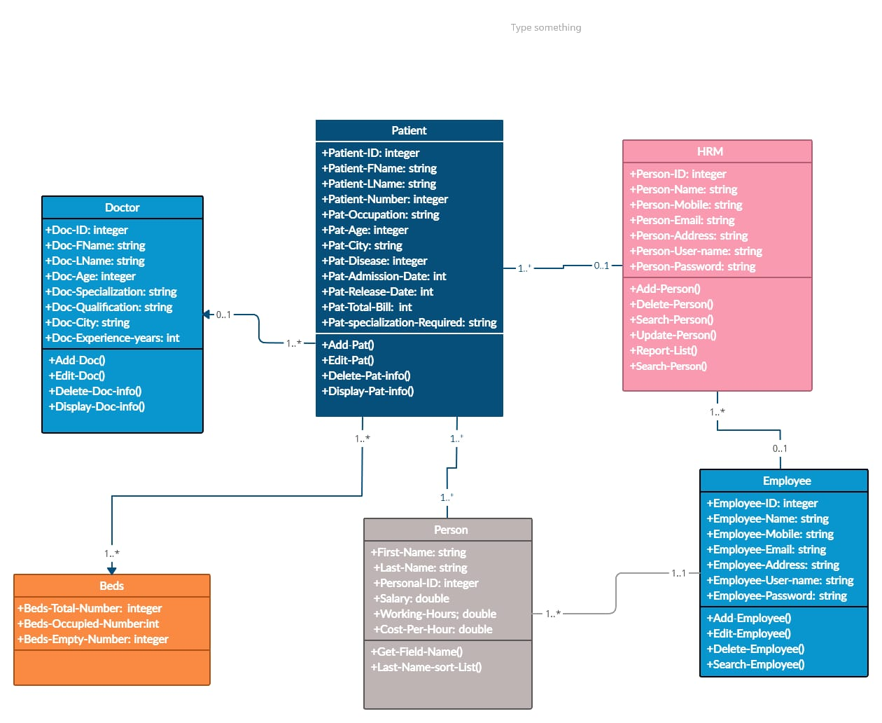

1. **USE CASE Diagram:**

A use case diagram is a form of behavioral diagram derived from a use-case study in the Unified Modeling Language (UML). The goal of this diagram in our hospital management system (HMS) is to show a graphical overview of a system's functionality in terms of actors, goals, and any dependencies between those use cases.

* **Use case diagram of our project:**

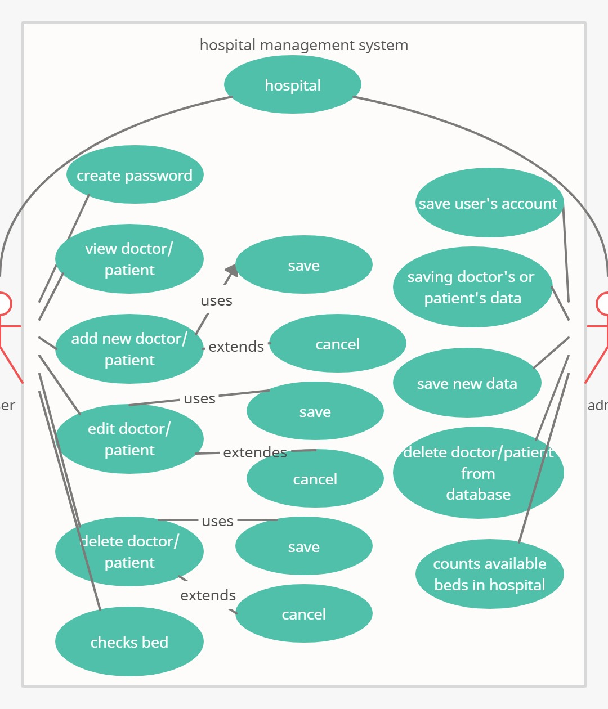

1. **Sequence diagram:**

We used sequence diagram here in our hospital management system in order to highlights the structural arrangement of the objects that send and receive messages.

* **Sequence diagram of our project:**

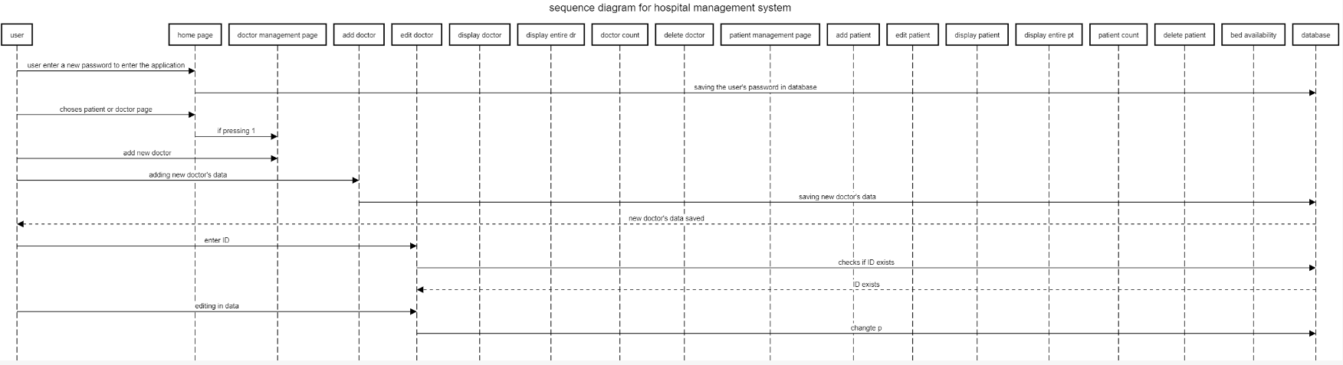

* 1. **Design Patterns**

Our project is built on a hospital management system, and we grant admin and user access to utilize the system independently, based on their constraints. We incorporated a number of modules that are required in the hospital management system; the administrator can use his or her own modules, and the user can use his or her own.

Our main goal in this project is to optimize the system and to tackle difficulties that arise frequently during the software development process. We are attempting to use Design Patterns to make this project more viable, efficient, and error-free.

**Our Project Design Patterns:**

**1.Delegation pattern**

Structural design pattern aims to reduce coupling between classes, enabling future extensions, and encapsulate complex structures. During the daily tasks of a doctor, there are some activities that can be delegated to nurse. That’s why sometimes you have doctor apply the first medicine but then followed up by nurses. using delegation pattern by having Doctor class to store reference to Nurse class and when needed, call the Nurse object for action delegation.

void doctor1::getDoctorDatabase() {

int choice_doc;

repeatDocDb:

std::cout<<"\n " <<"WELCOME TO DOCTOR'S DATABASE"<<"\n"<<"\n";

std::cout<<" "<<"1.Add New Doctor's Information"<<"\n";

std::cout<<" "<<"2.Edit a Doctor's Information"<<"\n";

std::cout<<" "<<"3.Display a Doctor's Information"<<"\n";

std::cout<<" "<<"4.Delete a Doctor's Information"<<"\n";

std::cout<<" "<<"5.Display Entire Doctor Database"<<"\n";

std::cout<<" "<<"6.Total Number of Doctors"<<"\n";

std::cout<<" "<<"7.Exit"<<"\n";

std::cout<<std::right<<std::setw(80)<<std::setfill('-')<<"----------"<<"\n";

std::cout<<std::right<<std::setw(60)<<std::setfill(' ')<<"\nEnter the number corresponding to your choice:"<<"\n"<<"\n";

std::cin>>choice_doc;

system("cls");

switch(choice_doc){

case 1:{

//addDoc()

addDoc();

break;

}

case 2:{

//editDoc()

doctor1 k;

editDoc(k)

**2.Adaptor pattern**

Structural pattern aims to reduce coupling between classes, enabling future extensions, and encapsulate complex structures. Adapter acts as a translator between 2 systems. This can be done by implementing interfaces, and override some methods from the new system and then make a delegation call.

3.**Proxy pattern**

Structural pattern provides a substitute for another object. A proxy controls access to the original object, allowing you to perform something either before or after the request gets through to the original object. the guardian acts as access control proxy. If the real patient can actually will to do said action that it will do it otherwise the proxy gets to decide.

void patient1::getPatientDatabase() {

int choice_pat;

repeatPtDb:

std::cout<<"\n "<<"WELCOME TO PATIENT'S DATABASE"<<"\n"<<"\n";

std::cout<<" "<<"1.Add New Patient's Information"<<"\n";

std::cout<<" "<<"2.Edit a Patient's Information"<<"\n";

std::cout<<" "<<"3.Display a Patient's Information"<<"\n";

std::cout<<" "<<"4.Delete a Patient's Information"<<"\n";

std::cout<<" "<<"5.Display Entire Patient Database"<<"\n";

std::cout<<" "<<"6.Total Number of Patients"<<"\n";

std::cout<<" "<<"7.Check for doctor availability"<<"\n";

std::cout<<" "<<"8.Exit"<<"\n";

std::cout<<std::right<<std::setw(80)<<std::setfill('-')<<"----------"<<"\n";

std::cout<<std::right<<std::setw(60)<<std::setfill(' ')<<"\nEnter the number corresponding to your choice:"<<"\n"<<"\n";

std::cin>>choice_pat; //input for choice

system("cls");

switch(choice_pat){

**4. state pattern**

Behavioral design patterns are concerned with algorithms and the assignment of responsibilities between objects. State lets an object alter its behavior when its internal state changes. It appears as if the object changed its class. Hospital describes patient’s condition in a medical state jargon. It will serve as a nice example for the needs of using State Pattern.

class patient1

{

//decleration for variable and funtion used in class

public:

std::string fname,lname,occupation,p_city,dis,addDate,relDate;

int p_age,p_ID;

long double phnumber,bill;

std::string getDept();

void getDoctor();

void addPat();

void editPat(patient1 &pat);

void displayPat();

void deletePat();

void dispPatDatabase();

void numberofPats();

void getPatientDatabase();

protected:

};

**5. observer pattern**

Behavioral design patterns are concerned with algorithms and the assignment of responsibilities between objects. Observer Lets you define a subscription mechanism to notify multiple objects about any events that happen to the object they’re observing. Each Doctor and nurse must have Observer implementation so that they can observe the patient information. And since they also modifying the Observable object, all changes will be observed and updated by other GUIs.

#include<fstream>

#include<string>

#include<conio.h>

#include<ctime>

#include<windows.h>

using namespace std;

class patient

{

public:

static int bill;static string name;static string phone ;static string address;static string age;

void getinfo( )

{

cout<<"==================================================="<<endl;

cout<<"ENTER THE NAME OF PATIENT : ";cin>>name;

cout<<"ENTER THE AGE OF PATIENT : ";cin>>age;

cout<<"ENTER THE ADDRESS OF PATIENT : ";cin>>address;

cout<<"ENTER THE PHONE OF PATIENT : ";cin>>phone;

cout<<"==================================================="<<endl;

cout<<"\n\n";

}

int getproblem()

{

char p;

cout<<"SELECT DEPARTMENT : 1.HEART 2.BONES 3.TEETH 4.STOMACH 5.EMERGENCY : ";cin>>p;

return p;

}

};

**6.Abstract factory**

Abstract is Creational design pattern deal with object creation mechanisms, trying to create objects in a manner suitable to the situation. The basic form of object creation could result in design problems or added complexity to the design. Consider the action of adding new doctor to the hospital. Every doctor has their degree and specialization and we might encounter one situation where we have a very competent doctor with multiple and maybe specialized skills. So, we create new doctor object with all the skills information.

#include<string>

#include<iostream>

class doctor1

{

public:

std::string d_fname,d_lname;

int d_ID, d_age,experience,d_totalno;

std::string qual,d_city;

std::string getSpec();

void addDoc();

void editDoc(doctor1 &docobj);

void displayDoc();

void deleteDoc();

void dispDatabase();

void numberofDocs();

void getDoctorDatabase();

protected:

};

#endif

1. **Results**

In our results section, we provided the output for our Hospital Management System, HR Management System, and Departments of our hospital.

**Code Screenshots:**

* In Hospital Management System:

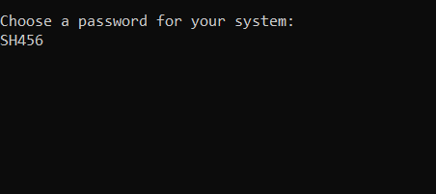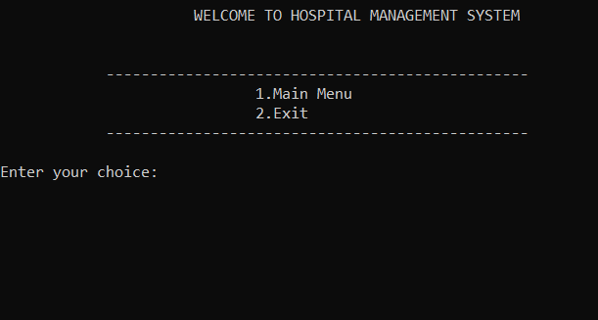

Figure (1&2) shows: the user chooses a password for his enrolling system, then he chooses Main Menu or to Exit his program

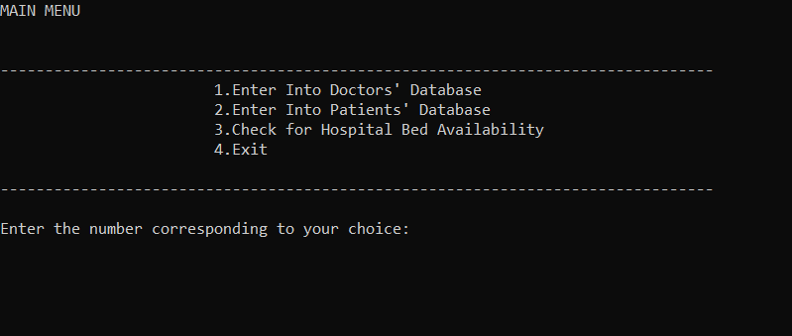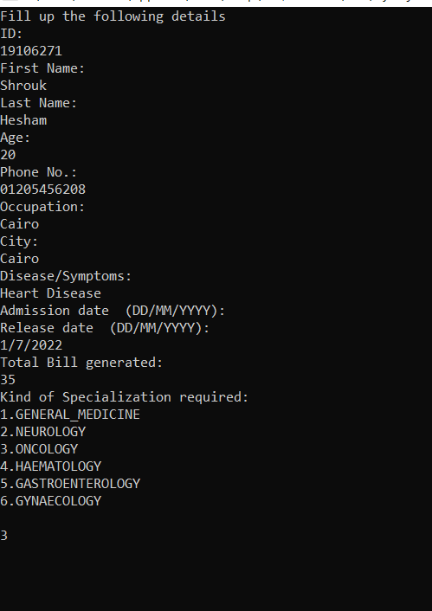

Figure (3&4) shows: After the user chooses Main Menu, he/she then have 4 options after he chooses the number corresponding to his/her choice, he then starts to enter personal data like ID, First Name, Age, City and other details as shown

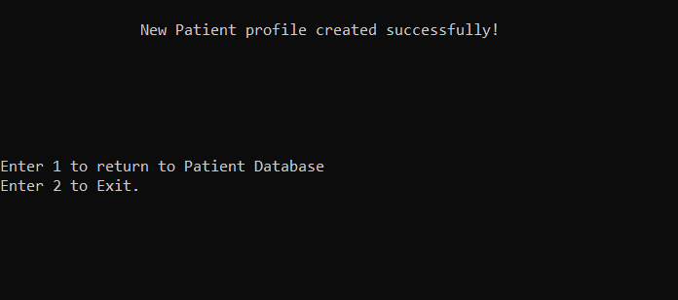

Figure (5) shows: After the user enters personal data, two options appear to return to his/her database or to exit.

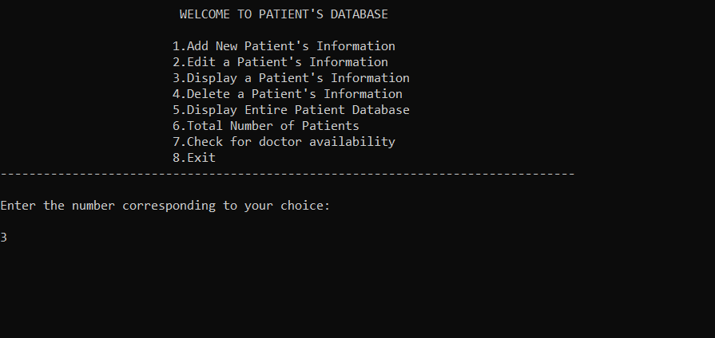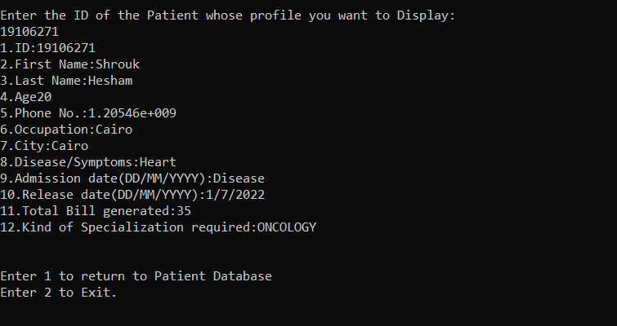

Figure (6 &7) shows: If the user chooses patient’s database, he/she then have many options to choose like add new patient, Edit, display, and other details. In the second figure, the patient profile I want to display profile for.

* In HR Management System:

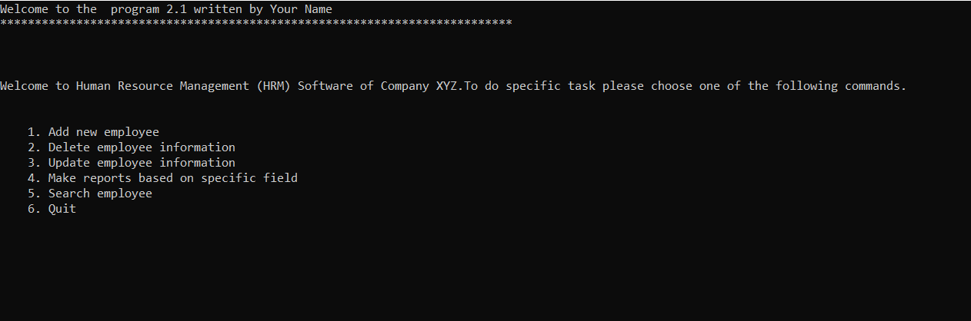

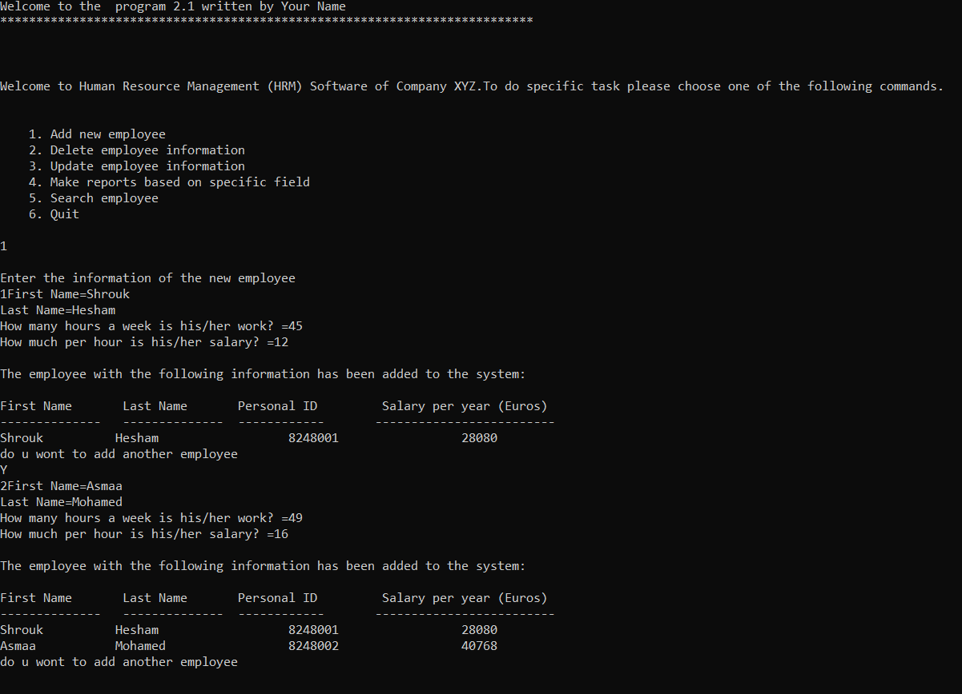

Figure (8&9) shows: in HR management system the user has many options after he enter the number of option wanted, then the user begins to enter his/her data.

* In Departments of our hospital Management system:

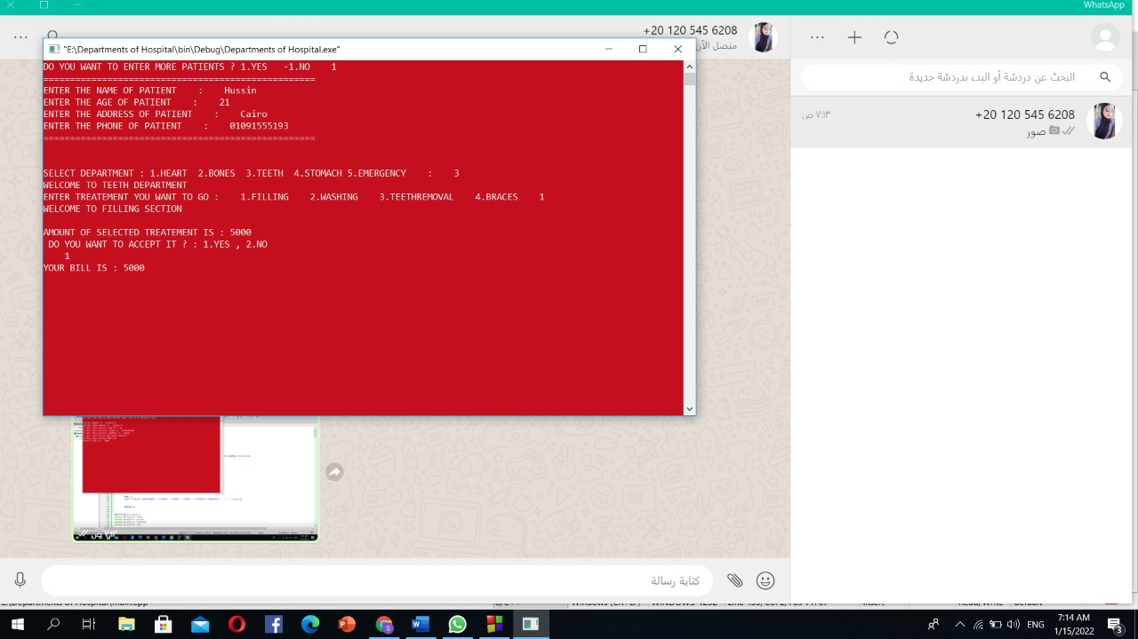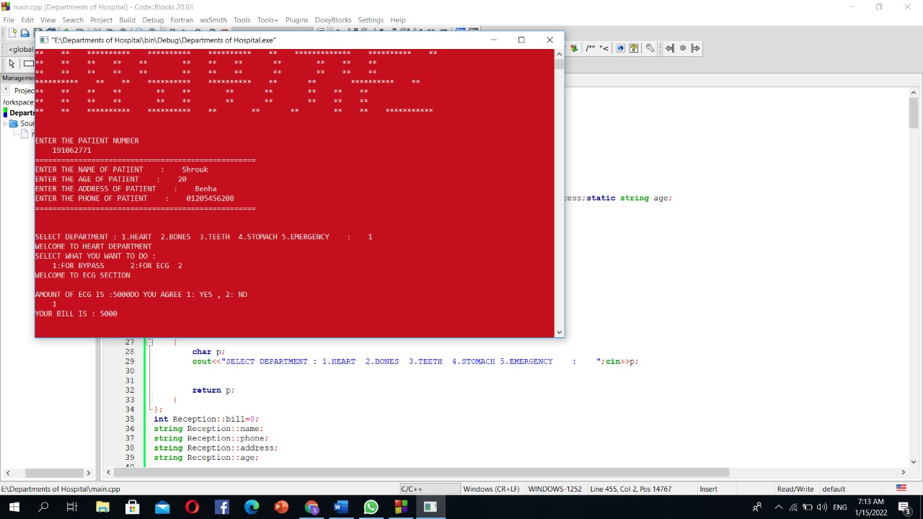

Figure (10 &11) shows: The user first enters personal information then choose the department he want to get treatment after that he chooses what specific treatment he want then a bill with cost was generated.

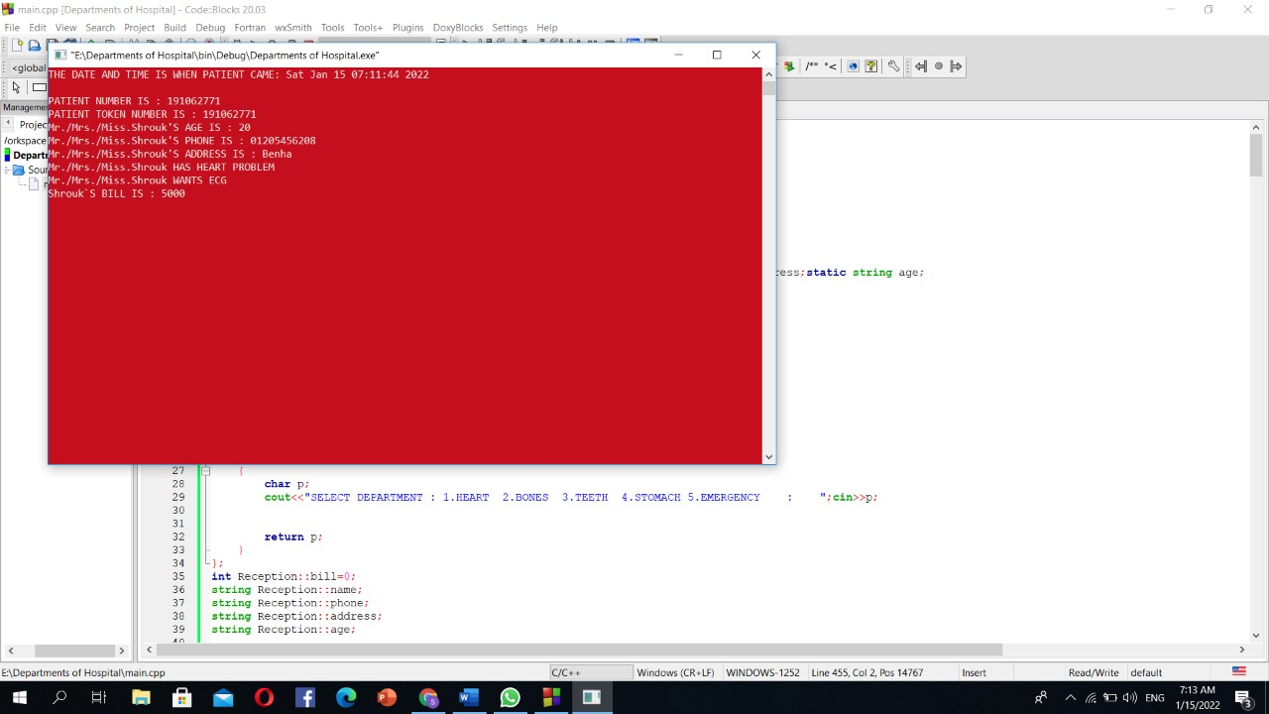

Figure (12) shows: After user entering personal information, his/her information displayed on a file.

1. **Discussions and conclusions**

The Hospital Management System (HMS) project aims to computerize hospital operations. The software meets all of the needs of a typical hospital and is capable of storing information about patients who visit the facility in a simple and efficient approach. In addition, it was created in order to improve the quality and management of hospital systems. Furthermore, our project has been a rewarding experience in more than one way. In addition, it enables you to develop your organization and improve its effectiveness and quality of work. In short, it is a comprehensive application that can efficiently record, maintain, and manage hospital affairs.

1. **Future Work & Suggestions**

In our project future work, we can update our system takes care of all the requirements of an average hospital and is capable to provide easy and effective storage of information related to patients that come up to the hospital. Such as generating test reports; provide prescription details including various tests, advices to patients, and medicines prescribed to patient and doctor. Furthermore use, analysis of the consequences of the system and the number of employees. Develop more sections needed by human resource such as performance assessment, and vocational training. In the future we will work on developing this project to be better in all aspects to be further customized to work for large or small hospitals.

1. **References**

* Nym. (July, 2021)"Hospital Management System" Retrieved from: <https://itsourcecode.com/fyp/hospital-management-system-project-report-documentations-pdf/> .
* Sarab, Sura. (2019). Hospital Management System. DOI:10.13140/RG.2.2.35189.19686.
* François P, Labarère J and Bontemps H (1997) Implementation of a documentation management system for quality assurance in a university hospital International Journal of Health Care Quality Assurance MCB UP Ltd 10(4): pp 156 - 160 7.
* Huarng F and Lee M H (1996) Using simulation in out-patient queues: a case study International Journal of Health Care Quality Assurance MCB UP Ltd 9(6): pp 21 - 25 8.
* Jones M (2004) Learning the lessons of history: Electronic records in the United Kingdom acute hospitals Health Informatics Journal SAGE Publications 10(4): pp 253-263 9.
* Karishma B and Ulrike R (2004) The use of a spatial information system in the management of HIV/AIDS in South Africa International Journal of Health Geographics 3(1)